Assignment -8

1) Assume each salesperson has 12% commision. Write query on the orders table, that will produce the order number, the salesperson number, and the amount of the salesperson commision for that order.
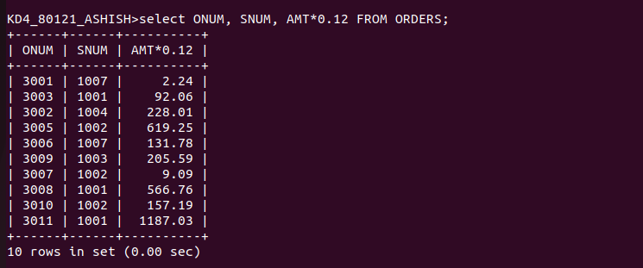

2)Write a querry on the Customers table that will find the highest rating in each city. Put the output in this form :
For the city (city), the highest rating is : (rating)
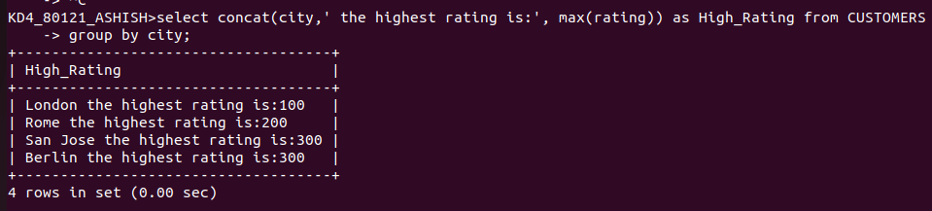

3)Write a query that lists customers in descending orders of rating. Output the rating field first


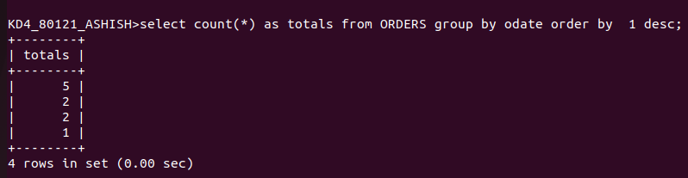
4) Write a query that totals the orders for each day and places the result in descending order.

